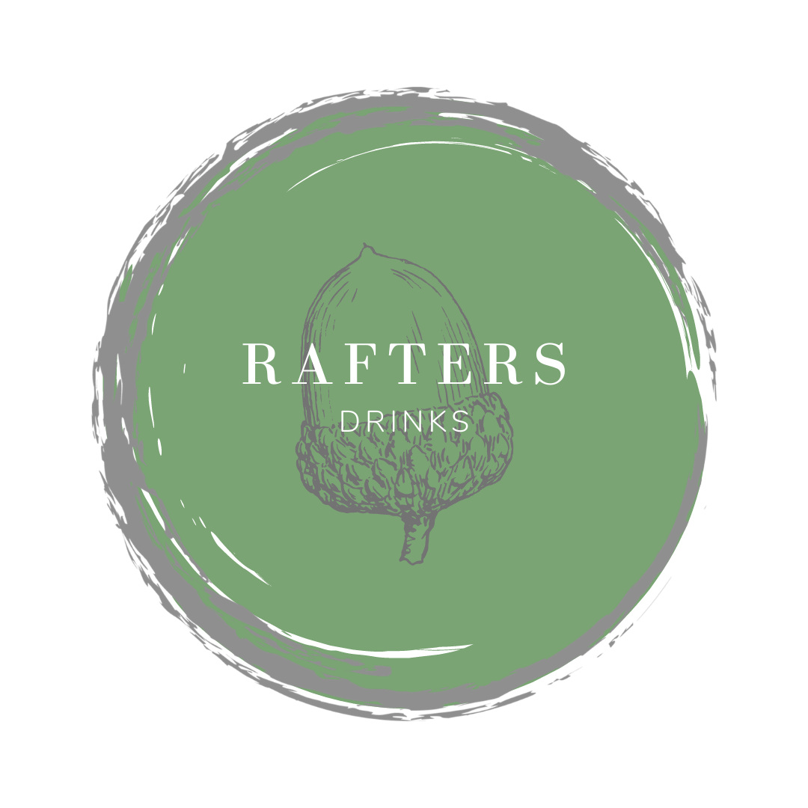
WELCOME
Our drink’s philosophy when sourcing our spirits and ingredients is simple.
British where possible, seasonal and above all tasty & delicious.

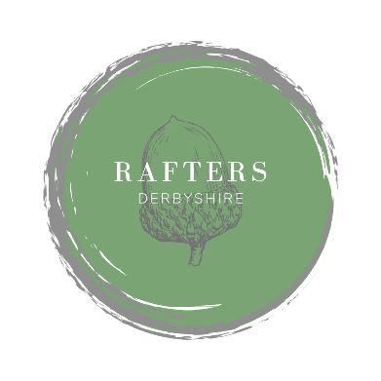
COCKTAILS - £12.00
CHERRY BRAMBLE
Shining Cliff Gin – Sugar – Lemon - Cherry
DIRTY MARTINI
Shinning Cliff Gin – Olive Brine – Dolin dry
BULLION CHOCOLATE ORANGE MARTINI
Bullion Liqueur – Cointreau – Dolin dry
APEROL SPRITZ
Aperol – Prosecco – Soda
PASSIONFRUIT MOJITO
Rum – Passionfruit Sugar – Lime – Soda – Mint
RIVERSIDE GARDEN SPRITZ
Riverside Gin – Lemon – St Germain – Mint, Basil, Cucumber
RHUBARB MAGARITA
Tequila – Cointreau – Yorkshire Rhubarb
ESPRESSO MARTINI
Vodka – Kahlua – Coffee
PIMMS & LEMONADE
NON-ALCOHOLIC COCKTAILS - £7.00
AMARETTO SOUR
Amaretto syrup – Lemon – Aquafaba
VIRGIN BLOODY MARY
Tomato Juice – Lemon – Tabasco – Salt – Pepper – Lea & Perrins
VIRGIN CHERRY BRAMBLE
Seedlip Spice – Sugar – Lemon - Cherry
NOT SO GIN & TONIC
Seedlip Citrus – Tonic – Chamomile – Juniper

IF YOU HAVE ANY ALLERGIES OR DIETARY REQUIRMENTS, PLEASE INFORM A MEMBER OF OUR TEAM

SOFT DRINKS
DIET COKE 330ml £3.50
COCA COLA 330ml £3.50
FENTIMANS GINGER BEER 275ml £3.50
FEVER-TREE GINGER ALE 200ml £2.00
FEVER-TREE TONIC 200ml £2.00
FEVER-TREE SLIMLINE TONIC 200ml £2.00
FEVER-TREE ELDERFLOWER TONIC 200ml £2.00
FEVER-TREE MEDITERRANEAN TONIC 200ml £2.00
FEVER-TREE LEMONADE 200ml £2.00
FEVER-TREE SODA 200ml £2.00
SCHWEPPES TOMATO JUICE 200ml £2.50
FRESH JUICE 250ml £2.50
Orange – Cranberry- Apple
BEERS / LAGERS
RAFTERS COLLABORATION LAGER 4.1% – 330ml £6.00
Gluten Free
Sheffield – England
JAIPUR IPA 5.9% - 330ml £6.00
Bakewell – England

ESTRELLA 4.6% – Pint / Half £3.00 / £6.00
Barcelona – Spain

BAKEWELL BEST 4.2% – 550ml £6.00
Bakewell – Derbyshire

ZERO FIVE 0.5% – LOW ALCOHOL - 330ml £5.00
Bakewell – Derbyshire

BITBURGER DRIVE – ALCOHOL FREE - 330ml £5.00
Germany

STRAWBERRY & LIME REKORDERLIG 4% – 500ml £6.00
Sweden

SPIRITS LIST – 25ml
RUM
SAILOR JERRY SPICED £7.00
HAVANA 3YR WHITE £5.00
HAVANA 7YR DARK £6.00
VODKA
GREY GOOSE £7.00
WHITTAKERS BARLEY MOW £6.00
GIN
HENDRICKS £7.00
EDINBURGH RHUBARB & GINGER £6.50
MONKEY 47 £8.00
RAFTERS CO-LAB £7.00
RIVERSIDE GIN £8.00
SHINING CLIFF £7.00

TEQUILA
JOSE CERUO SILVER £4.50
TAPATIO REPOSADO £4.50
LIQUEURS / APERITIFS – 50ml
BAILEYS £8.00
COINTREAU £8.00
CAMPARI £8.00
TIA MARIA £8.00
BULLION CHOCOLATE £7.50
AMARETTO £8.00
NON-ALCOHOLIC
SEEDLIP CITRUS £5.00

WINE BY THE GLASS – 125ml
SPARKLING
GUSBOURNE BLANC DE BLANCS £13.00
Kent, England - A superb lockdown find! Tom found this listening
to a chef’s podcast; a taste and we were hooked. Its stunning.
PROSECCO DOC, SAVIAN £8.00
Great quality, perfect for Prosecco lovers

WHITE
WHITE RIOJA 2018, CONTINO £10.00 Rioja, Spain - An elegant floral nose and spices from French oak.
Your go to full bodied wine
ALBARINO 2020, BODEGA LEDAS £6.00
Rias Baixas, Spain - Want something new? This is the answer!
SAUVIGNON BLANC 2021, CLOUDY BAY £11.00
Marlborough, New Zealand – Claims are made this is the original
Kiwi Sauvignon Blanc
GEWURTZTRAMINER 2018, BRUNO SORG £11.00
Alsace, France- Full and rich tropical fruits, with a touch of sweetness

ROSE
DOMAINE HENRI GAILLARD 2020 £6.00
Provence, France - The rose at the moment. Provence is
clean and easy going easy to see why it’s so popular

RED
VENETTO ROSSO 2020, GRAN PASSIONE £6.00
Vento, Italy - Merlot given the Amarone treatment, Amarone
drinkers stop here
JONTY’S DUCK 2015, AVONDALE £8.00
Paarl, South Africa - A blend of Syrah, Cabernet Sauvignon,
Merlot and Cabernet Franc, superbly rich and spicy
MENDAL UNUS 2018, ROBERTO DE LA MOTA £11.00
Mendoza, Argentina - A Malbec blend with Cabernet Sauvignon,
full bodied and wonderfully complex
MOULIN-À-VENT 2014, DOMAINE MERLIN £10.00
Burgundy, France - One of the ten crus of Beaujolais,
well ripened cherry and velvety tannins

COFFEE
We work closely with Sheffield Coffee Roaster Roast Ology with who, we have created our own espresso blend.
AMERICANO £4.25
CAPPUCINO £4.50
LATTE £4.50
FLAT WHITE £4.50
ESPRESSO / DOUBLE ESPRESSO £2.50 /£3.50
MACCHIATO / DOUBLE MACCHIATO £3.00 / £4.00
LIQUEUR COFFEE £7.75
- Irish whiskey
- Baileys
- Tia Maria
TEAS / INFUSIONS
BREAKFAST TEA £4.25
EARL GREY £4.25
CHAMOMILE £4.25
MOROCCAN MINT £4.25
APPLE AND BLACKBERRY £4.25
LEMON & GINGER £4.25
YUNNAN GREEN £4.25
DECAF CEYLON £4.25
CAKES
RIVERSIDE SCONE, CLOTTED CREAM & JAM £5.00
GLUTEN FREE AVAILABLE

IF YOU HAVE ANY ALLERGIES OR DIETARY REQUIRMENTS, PLEASE INFORM A MEMBER OF OUR TEAM

AFTER DINNER – 25ml
Whisky / Whiskey
WIRE WORKS
First Release Single Malt, White Peak Distillery
Derbyshire, England £10.00
THE ENGLISH, SINGLE CASK SMOKEY
Norfolk, England £9.00
ARDBEG 10YR – Scotland £6.00
GLENFARCLAS 10YR – Scotland £5.00
NIKKA FROM THE BAREL – Japan £12.00
PIG’S NOSE BLENDED WHISKY – Scotland £4.00
JAMESON'S IRISH WHISKEY – Ireland £5.25
BULLEIT BOURBON – USA £6.00
Cognac / Armagnac
H BY HINE VSOP – COGNAC – France £8.00
HENNESSY XO – COGNAC – France £20.00
BARON DE SIGOGNAC, ARMAGNAC 20YR – France £12.00
BARON DE SIGOGNAC, ARMAGNAC 10YR – France £7.00
PORT – 50ml
POCAS 10YR TAWNY £5.50
POCAS 20YR TAWNY £12.00
NIEPORT LBV 2017 £5.00
SIMMINGTONS QUINTA DO VESUVIO 1999 £8.50
POCAS COLHEITA 1964 TAWNY £22.00

